SMART HOUSE A35dV

A35dV | Dimensions | Powierzchnia zabudowy: | Powierzchnia wewnętrzna:
 | 3.60 x 9.60 x 3.90 m | 34.56 m² | 32.38 m²

 | 4+2 |  | 2 |  | 1 |  | 1 | 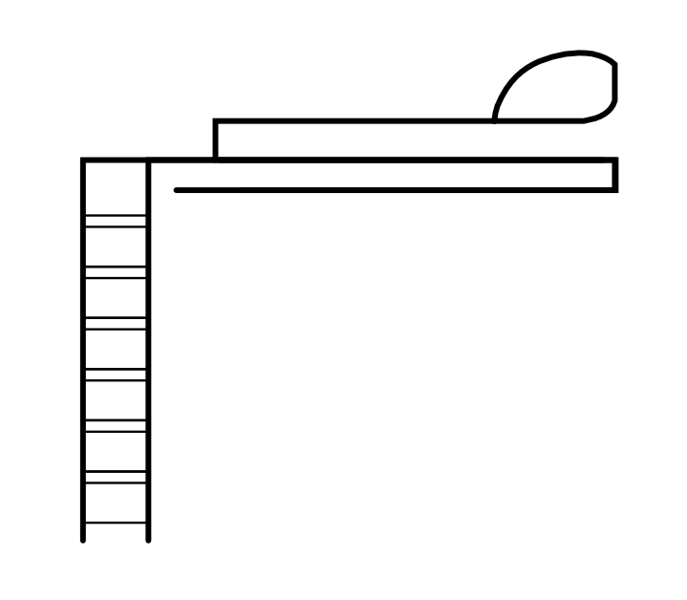 | 1
 | gable  roof |  | facade:  -wood  -steel |  | all-year product |  | 1

Smart House A35dV is a year-round house, designed in modular technology, on a single steel frame, with a gable roof. The functionally arranged space allowed to separate a living room with a kitchenette, a bathroom and a bedroom with a large bed. An additional zone has been created as a mezzanine with a place that provides comfortable accommodation for two people. The day zone with large glazing allows you to enjoy the views outside the window. The main advantage is the building area - up to 35m2.
This is a house designed for those who appreciate a cozy compact space.

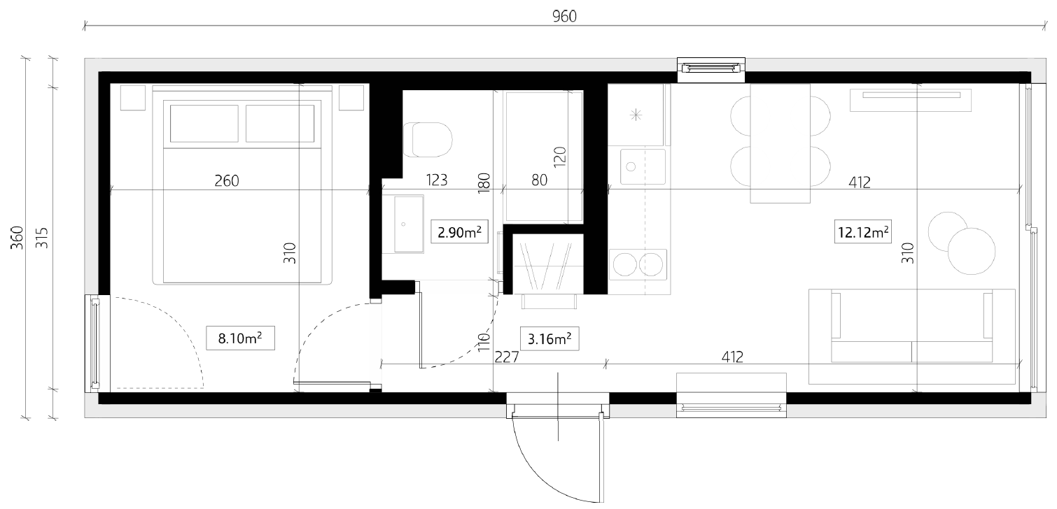
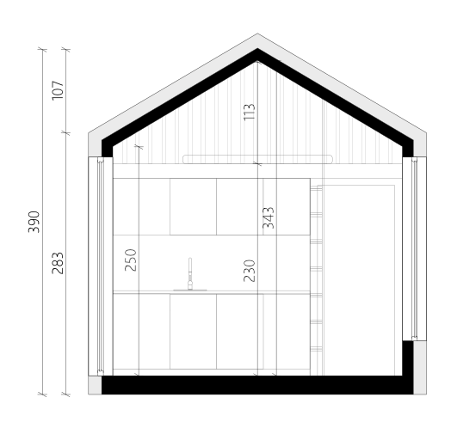 | room area | m²  living room + kitchen 12.12 m²  cabinet 3.16 m²  bathroom 2.90 m²  bedroom 8.10 m²  usable area 26.28 m²  - mezzanine 6.10 m²  internal area 32.38 m²

